Lesson 3 Demo 6: Push an Image to Docker Hub

This section will guide you to:

* Push an image to Docker Hub

**Step 1**: Create a Docker image from the Dockerfile

* Use the following commands to create a directory and navigate to it:

*mkdir pythonapp*

*cd pythonapp*

* Use the following command to create a Python app:

*nano app.py*

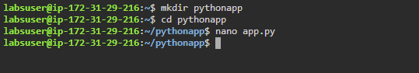

* Write the following code in the *app.py* file:

*from flask import Flask*

*import os*

*import socketapp = Flask(__name__)@app.route(“/”)def hello():*

*html = “<h3>Hello {name}!</h3>” *

*“<b>Hostname:</b> {hostname}<br/>”*

*return html.format(name=os.getenv(“NAME”, “world”), hostname=socket.gethostname()) if __name__ == “__main__”:*

*app.run(host=’0.0.0.0', port=80)*

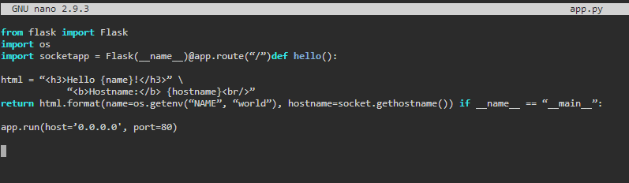

**Note**: Press **Ctrl+X** to exit the editor. Then type **Y** and press **Enter** to save the file.

* Use the following command to create a *requirements.txt* file:

*nano requirements.txt*

**

* Write the following code in the *requirements.txt* file:

*Flask*

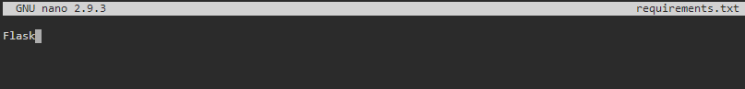

**Note**: Press **Ctrl+X** to exit the editor. Then type **Y** and press **Enter** to save the file.

* Use the following command to create a Dockerfile:

*nano Dockerfile*



* Write the following code in the *Dockerfile*:

*FROM python*

*WORKDIR /app*

*ADD . /app*

*RUN pip install -r requirements.txt*

*EXPOSE 80*

*ENV NAME world*

*CMD [“python”, “app.py”]*

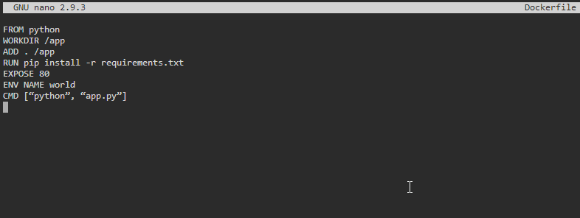

**Note**: Press **Ctrl+X** to exit the editor. Then type **Y** and press **Enter** to save the file.

* Use the following command to list all the files created in the **pythonapp** folder:

*ls*

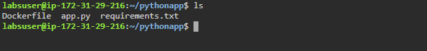

* Build the Docker image from the newly created *Dockerfile*

*sudo* *docker build -t python_image .*

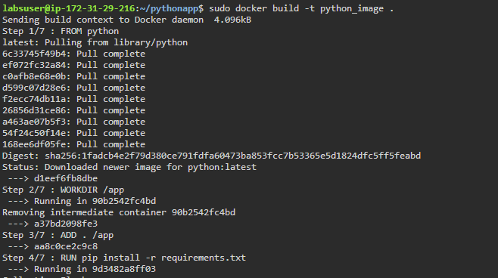

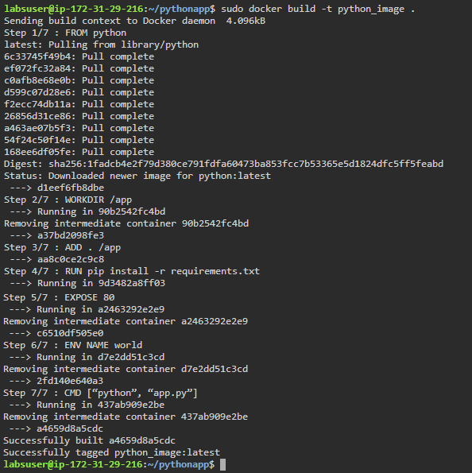

* List all the running images to check the newly created image

*sudo docker images*

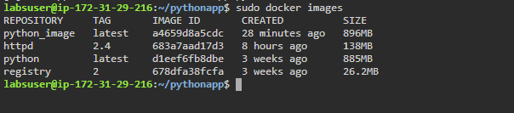

**Step 2:** Push the image to a Docker Hub repository

**Note:** In case you do not have a Docker Hub account, navigate to [hub.docker.com](https://hub.docker.com/) and create an account.

* Use the following command to log in to your Docker Hub account:

*sudo docker login*

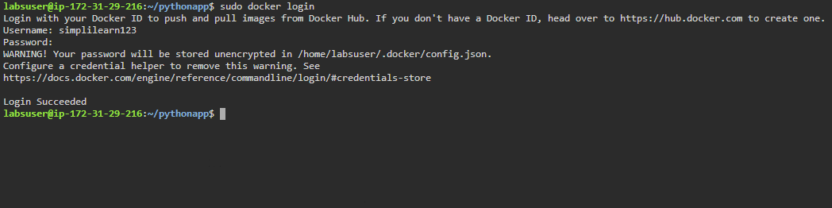

* Use the following command to tag the Docker image:

*sudo docker tag python_image USERNAME/python_image:version1*

***Note:*** *Replace USERNAME with the username of your Docker Hub account.*

* Use the following command to push the Docker image to your Docker Hub repository:

*sudo docker push USERNAME/python_image:version1*

***Note:*** *Replace USERNAME with the username of your Docker Hub account.*

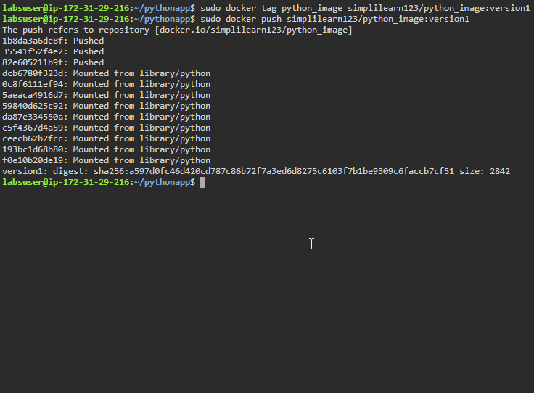

* Go to your Docker Hub account and navigate to ***Repositories*** to see your recently pushed image

